**Understanding Django Signals**

[[Anand Rathore](https://medium.com/@av44314?source=post_page-----346ba0c8a148--------------------------------)](https://medium.com/@av44314?source=post_page-----346ba0c8a148--------------------------------)

[[Towards Dev](https://towardsdev.com/?source=post_page-----346ba0c8a148--------------------------------)](https://towardsdev.com/?source=post_page-----346ba0c8a148--------------------------------)

[Anand Rathore](https://medium.com/@av44314?source=post_page-----346ba0c8a148--------------------------------)

·

[Follow](https://medium.com/m/signin?actionUrl=https%3A%2F%2Fmedium.com%2F_%2Fsubscribe%2Fuser%2F93340a0613ee&operation=register&redirect=https%3A%2F%2Ftowardsdev.com%2Funderstanding-django-signals-346ba0c8a148&user=Anand+Rathore&userId=93340a0613ee&source=post_page-93340a0613ee----346ba0c8a148---------------------post_header-----------)

Published in

[Towards Dev](https://towardsdev.com/?source=post_page-----346ba0c8a148--------------------------------)

·

5 min read

·

15 hours ago

10

Explore the comprehensive guide to Django Signals, covering their benefits, usage, and best practices. Enhance your Django skills with this in-depth tutorial & examples.

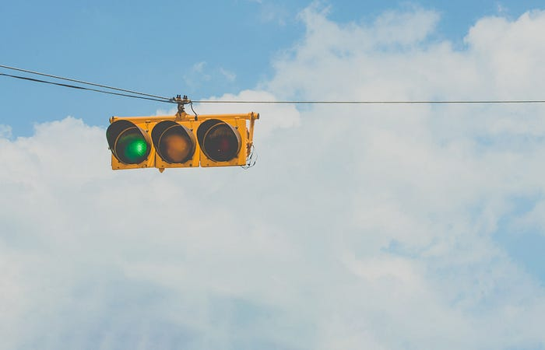

Photo by [Carlos Alberto Gómez Iñiguez](https://unsplash.com/@iniguez?utm_source=medium&utm_medium=referral) on [Unsplash](https://unsplash.com/?utm_source=medium&utm_medium=referral)

**1. Introduction to Django Signals**

In the world of Django, a powerful web framework for Python, **“signals”** refers to a strategy that allows certain senders to notify a set of receivers when certain actions or events occur. They are essentially a form of the Observer design pattern, enabling loose coupling between components in a Django application.

**2. What are Django Signals?**

Django signals are a form of message passing. When an event, such as saving a model or sending a request, occurs in Django, a signal can be sent. This signal can be picked up by any receiver that is listening for it, allowing the receiver to execute a function in response to the event.

**3. Benefits of Using Django Signals**

1. **Decoupling:** Signals allow decoupling of code in Django applications. The sender of a signal does not need to know which function needs to be called in response. This separation of concerns makes the codebase more maintainable.
2. **Extensibility:**They allow developers to plug into various parts of Django’s framework and add or modify functionalities. This can be particularly useful in larger projects where multiple apps are interacting.
3. **Notification System:**They act as a notification system within the Django project. Various parts of the application can be notified when certain actions are performed.

**4. Common Use Cases**

* **Model Changes:**To perform an action after saving, updating, or deleting an instance of a model.
* **User Actions:** For example, sending an email notification when a user registers.
* **Custom Signals:** Creating custom signals for specific application needs.

**5. How to Use Django Signals**

Here’s a step-by-step example of how to use Django signals:

**Step 1: Import Required Modules**

First, import the necessary modules for signals. You’ll typically need signals from django.db.models and receiver from django.dispatch.

from django.db.models.signals import post_save  
from django.dispatch import receiver  
from myapp.models import MyModel

**Step 2: Define the Signal Receiver**

A receiver is a function that gets called when the signal is sent. You’ll use the @receiver decorator to designate a function as a signal receiver. Let's say you want to perform an action every time an instance of MyModel is saved:

@receiver(post_save, sender=MyModel)  
def my_model_post_save(sender, instance, created, **kwargs):  
 if created:  
 print(f"A new record created: {instance}")  
 else:  
 print(f"Record updated: {instance}")

In this function, post_save is a signal that is sent by Django whenever a model instance is saved. The sender argument specifies which model class is sending the signal (in this case, MyModel). The instance argument is the actual instance of MyModel being saved, and created is a boolean indicating whether this instance is being created (**True**) or updated (**False**).

**Step 3: Connect the Signal**

You have two ways to connect the signal to the receiver:

**Method 1: Using the @receiver Decorator**

The above example uses the @receiver decorator to connect the signal to the receiver function. This method is straightforward and commonly used.

**Method 2: Using the Signal.connect() Method**

Alternatively, you can explicitly connect the signal to the receiver function:

post_save.connect(my_model_post_save, sender=MyModel)

This line should be placed after the receiver function definition, often at the bottom of your models.py file or in a separate signals.py file within your Django app.

**5.1. Example Use Case**

Let’s say MyModel represents a user profile, and you want to send a welcome email each time a new user profile is created. Your signal receiver function might look like this:

@receiver(post_save, sender=MyModel)  
def send_welcome_email(sender, instance, created, **kwargs):  
 if created:  
 send_email_function(to=instance.email, subject="Welcome!", message="Thanks for joining us!")

In this example, send_email_function would be a function you've defined elsewhere to handle sending emails.

**6. Custom Signals in Django**

Creating and using custom signals in Django can be a powerful way to decouple various parts of your application and make it more flexible and maintainable. Below is a detailed explanation of how to create custom signals and how to use them effectively, complete with an example.

**6.1. What are Custom Signals?**

Custom signals in Django are user-defined signals that you create for specific purposes in your application. Unlike built-in signals provided by Django (like post_save, pre_delete, etc.), custom signals are tailored for specific actions or events in your application.

**6.2. Creating Custom Signals**

To create a custom signal, you use Django’s **Signal** class. This class is located in django.dispatch.

**Step 1: Defining a Custom Signal**

Suppose you want to send a signal when a user completes a specific action in your app, like finishing a task.

First, define your custom signal in a signals.py file within your Django app:

# myapp/signals.py  
from django.dispatch import Signal  
  
# Defining a custom signal  
task_completed = Signal(providing_args=["task", "user"])

In this example, task_completed is the custom signal that will be sent when a task is completed. The providing_args parameter is optional but recommended as it provides clarity on what arguments the signal expects.

**Step 2: Connecting Signals to Receivers**

A signal needs to be connected to a receiver function, which is triggered when the signal is sent. Create a receiver function that will be called when your custom signal is sent.

# myapp/receivers.py  
from django.dispatch import receiver  
from .signals import task_completed  
  
@receiver(task_completed)  
def handle_task_completion(sender, **kwargs):  
 task = kwargs.get('task')  
 user = kwargs.get('user')  
 print(f"Task {task} completed by {user}.")

In this example, handle_task_completion is the receiver function that handles the task_completed signal. The @receiver decorator connects this function to the task_completed signal.

**Step 3: Sending Signals**

After defining and connecting your custom signals to receivers, you can send these signals from anywhere in your app. Let’s say you want to send the task_completed signal when a user completes a task.

# myapp/views.py (or any other module)  
from .signals import task_completed  
  
def complete_task(request, task_id):  
 # Logic to complete the task  
 task = ... # Get the task instance  
 user = request.user  
  
 # Send the task_completed signal  
 task_completed.send(sender=user.__class__, task=task, user=user)  
  
 # Rest of the view logic

In this view, when a task is completed, the task_completed signal is sent with the task and user as arguments.

**7. Pros and Cons of Using Django Signals**

**7.1. Pros**

1. **Cleaner Code:** Helps in keeping the business logic out of models and views.
2. **Asynchronous Processing:** This can be used to trigger background tasks.
3. **Flexibility:**Offers a flexible way to plug into Django’s built-in class-based views and models.

**7.2. Cons**

1. **Debugging Difficulty:**Tracking the flow of signals can be challenging, making debugging harder.
2. **Overuse Risks:**Excessive use of signals can lead to spaghetti code that’s hard to trace and maintain.
3. **Performance Concerns:**If not used carefully, signals can lead to unexpected database queries, impacting performance.

**8. Pitfalls and Best Practices**

1. Avoid Overusing Signals: Use signals only when necessary. Sometimes overriding model’s save method or using middleware is a better choice.
2. Keep Signal Handlers Light: Signal handlers should be lightweight to prevent performance issues.
3. Documentation: Document the use of signals and their connections clearly in your project.

**9. Conclusion**

Django signals provide a powerful and flexible way to handle events and notifications within a Django application. When used judiciously, they can greatly enhance the extensibility and maintainability of your code. However, they should be used sparingly and with care to avoid potential pitfalls like making the codebase hard to understand and maintain.

By understanding the benefits and drawbacks of Django signals and following best practices, you can effectively utilize this feature to create clean, efficient, and robust Django applications.

**Also Read:**

[How to Build a Web Application with Django](https://codesarray.com/view/How-to-Build-a-Web-Application-with-Django)

[Python](https://medium.com/tag/python?source=post_page-----346ba0c8a148---------------python-----------------)

[Django](https://medium.com/tag/django?source=post_page-----346ba0c8a148---------------django-----------------)

[Django Rest Framework](https://medium.com/tag/django-rest-framework?source=post_page-----346ba0c8a148---------------django_rest_framework-----------------)

[Web Development](https://medium.com/tag/web-development?source=post_page-----346ba0c8a148---------------web_development-----------------)

[Software Development](https://medium.com/tag/software-development?source=post_page-----346ba0c8a148---------------software_development-----------------)